Personal project
May 2024
-
May 2024
Data & Analytics

Paris Commute Comparison - Bike vs. Metro

Sayuj Thennat

Introduction
As a frequent commuter in Paris, the daily journey can sometimes be a challenge. The bustling metro, while efficient, can become overwhelming during peak hours. Conversely, cycling offers an alternative that promises fresh air and freedom but raises questions about efficiency. This project aims to provide a clear comparison between cycling and metro commute times to the Notre-Dame Cathedral from various parts of Paris. The goal is to help commuters make informed decisions about their daily travel.

Motivation
The motivation behind this project stems from personal experience. Navigating the Parisian streets and the metro system daily, I often wondered whether cycling would be a faster and more pleasant alternative. This curiosity drove the creation of a comprehensive visualization that could answer this question not just for me but for all Parisians.

Data Sources
To create an accurate and informative comparison, the project relies on multiple data sources:
Google Maps API:
Used to fetch cycling times from various points in Paris to the Notre-Dame Cathedral.
API Key: Provided for access.

Île-de-France Mobilités Open Data:

Accessed GTFS (General Transit Feed Specification) data for public transit schedules and routes.

Data includes walking, waiting, riding, and transferring times.

OpenStreetMap (OSM):

Provided the geographic data required for the visualization.

Tools and Technologies

Python: The primary programming language used for data processing and visualization.

R5py: A Python library designed for transportation analysis, built on top of the open-source R5 routing engine by Conveyal.

Geopandas: Used for geospatial data manipulation and analysis.

Folium: Utilized for creating interactive maps.

BeautifulSoup: A Python library for parsing HTML and extracting data.

Methodology
Step 1: Data Collection

Google Maps API: Retrieved cycling times for a grid of points evenly spaced throughout Paris.

GTFS Data: Downloaded from Île-de-France Mobilités Open Data to compute metro travel times.

Step 2: Data Processing

Hexagonal Grid Creation:

Created a regular hexagonal grid of points to cover the city of Paris.

Ensured comprehensive spatial coverage to provide detailed insights.

Travel Time Calculation:

Cycling Times: Calculated based on distance, assuming a constant speed of 15 km/h.

Metro Times: Computed using R5py, accounting for the entire trip duration (walking to the stop, waiting, riding, transferring, and walking to the destination).

Step 3: Visualization

Data Integration:

Combined cycling and metro times into a single GeoDataFrame.

Merged based on the centroids of the hexagonal grid cells.

Comparison Analysis:

Determined the faster mode of transportation for each hexagonal cell.

Used a color-coded system to represent areas where cycling is faster (shades of orange) versus areas where the metro is faster (shades of purple).

Interactive Map Creation:

Utilized Folium to create an interactive map with tooltips and a legend.

Provided a user-friendly interface to explore the data.

Results
The final output is an interactive map that clearly shows which areas of Paris are better served by cycling versus the metro. The map is color-coded:

Orange Shades: Faster by bike.

Purple Shades: Faster by metro.

Grey: No data available.

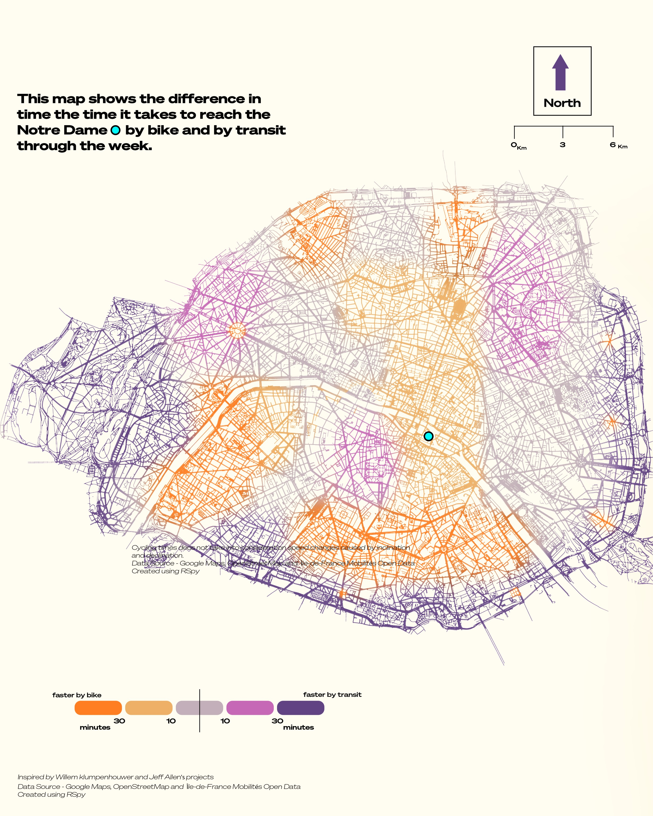

Conclusion
This project offers valuable insights into the efficiency of cycling versus metro travel in Paris. It serves as a practical tool for commuters to optimize their daily travel, potentially saving time and enhancing the commuting experience. By leveraging open data and modern geospatial analysis techniques, this project contributes to a more informed and connected urban mobility landscape.

Acknowledgments

Google Maps: For providing API access to cycling times data.

Île-de-France Mobilités: For making GTFS data publicly available.

OpenStreetMap: For providing geographic data.

Conveyal: For developing the R5 routing engine and R5py library.

Dominant Colors in Movie Posters Over Time


Sayuj Thennat

Introduction
This project explores the dominant colors in movie posters from different eras. By analyzing movie posters, we can gain insights into visual trends and artistic preferences over time. This project combines my passion for movies, design, and data analysis to reveal fascinating patterns in the color palettes of movie posters.

Objective

To extract the most dominant colors from movie posters.

To analyze how these dominant colors have changed over different periods.

To visualize the findings in an informative and aesthetically pleasing manner.

Dataset
The dataset consists of 100 movie posters downloaded from IMDb. The filenames are structured as follows:
<imdb_rating>_<imdb_id>.<file_extension>

Tools and Libraries

Python

OpenCV for image processing

scikit-learn for KMeans clustering

matplotlib for visualization

os and re for file handling

Step-by-Step Implementation

Step 1: Install Required Libraries
First, ensure you have the necessary libraries installed:

pip install opencv-python-headless scikit-learn matplotlib

Step 2: Extract Dominant Colors from Posters
We will use KMeans clustering to find the 20 most dominant colors in each poster.
python
import os import cv2 import numpy as np from sklearn.cluster import KMeans import matplotlib.pyplot as plt # Path to your folder folder_path = '/path/to/your/posters' def extract_dominant_colors(image_path, num_colors=20): # Read the image image = cv2.imread(image_path) # Convert the image from BGR to RGB format image = cv2.cvtColor(image, cv2.COLOR_BGR2RGB) # Reshape the image to be a list of pixels pixels = image.reshape(-1, 3) # Using KMeans to find clusters kmeans = KMeans(n_clusters=num_colors) kmeans.fit(pixels) # The cluster centers are our dominant colors. dominant_colors = kmeans.cluster_centers_ return dominant_colors def plot_colors(colors): plt.figure(figsize=(12, 2)) plt.imshow([colors.astype(int)]) plt.axis('off') plt.show() # Process each poster in the folder for filename in os.listdir(folder_path): if filename.endswith(('.png', '.jpg', '.jpeg')): image_path = os.path.join(folder_path, filename) dominant_colors = extract_dominant_colors(image_path) print(f'Dominant colors for {filename}:') plot_colors(dominant_colors)

Step 3: Visualize the Results
The plot_colors function will display the dominant colors in a visual format.

Step 4: Create the Final Visualization
Using matplotlib, we can create a comprehensive visualization of the most dominant colors over different periods.
python
import matplotlib.pyplot as plt import numpy as np # Dummy data for visualization purposes periods = ['2020 and After', 'Early 2010s', 'Early 2000s', 'Early 1900s'] colors = [ ['#4B0082', '#D2B48C', '#FFA500', '#4682B4', '#FF4500'], ['#B0E0E6', '#2E8B57', '#FFD700', '#FF6347', '#000000'], ['#000000', '#D2B48C', '#8B4513', '#FFA500', '#000000'], ['#2F4F4F', '#87CEEB', '#D2B48C', '#F5F5F5', '#8B4513'] ] fig, ax = plt.subplots(figsize=(10, 6)) for i, period in enumerate(periods): y = 0.5 for j, color in enumerate(colors[i]): ax.add_patch(plt.Circle((i, y), 0.1, color=color)) y -= 0.1 ax.text(i, 0.55, period, ha='center', va='center', fontsize=12) ax.set_xlim(-0.5, len(periods) - 0.5) ax.set_ylim(0, 1) ax.set_xticks([]) ax.set_yticks([]) ax.set_title('Most Dominant Colors in Movie Posters Over Time', fontsize=16) plt.show()

Step 5: Analyze the Results
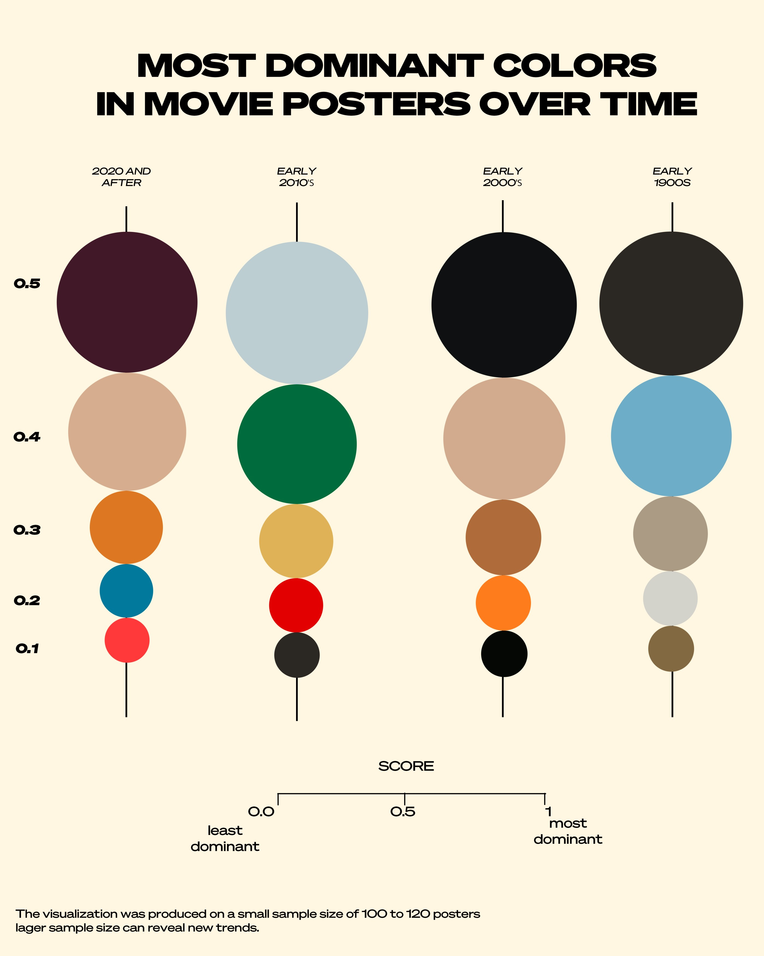
From the visualization, we can observe the following trends:

2020 and After: Darker, moodier colors dominate, indicating a trend towards more dramatic themes.

Early 2010s: Bright, vibrant colors are prevalent, suggesting a period of optimism and lively storytelling.

Early 2000s: A mix of dark and earthy tones, reflecting a balance between dramatic and grounded narratives.

Early 1900s: Earthy and subdued tones dominate, characteristic of the vintage aesthetic of that era.

Conclusion
This project successfully demonstrates how dominant colors in movie posters have evolved over time. The insights gained from this analysis can inform both artistic and marketing strategies in the film industry. While this study is based on a smaller dataset of 100 posters, expanding the dataset could provide more comprehensive insights.

Future Work

Increase the dataset size to include more movie posters for a more detailed analysis.

Explore correlations between dominant colors and movie genres.

Analyze the impact of movie poster colors on audience reception and box office success.

Analysis of Bike Availability in Paris Office Zones


Sayuj Thennat

INTRODUCTION

In recent years, the use of bicycles for daily commuting in Paris has significantly increased, particularly with the rise of public bike-sharing systems like Vélib'. With many Parisians now using bicycles as a primary mode of transportation to work, understanding the dynamics of bike availability across the city’s major office zones is critical. This project aims to analyze the availability of Vélib' bikes and docking stations in key business districts like La Défense, Opéra, Montparnasse, and others.

The objective of this analysis is to uncover trends in bike usage and availability, helping city planners, businesses, and residents optimize their commuting strategies and enhance urban mobility. This document outlines the full scope of the project, detailing the data, methodology, results, and future directions.

PROJECT OBJECTIVES

The primary goals of the project are:

To analyze the availability of Vélib' bikes (both mechanical and electric) across major office zones in Paris.

To understand the distribution of docking stations and available bike slots in these areas.

To track fluctuations in bike availability during peak office commuting hours and identify areas with potential shortages.

To create a foundation for future visualizations (e.g., animated changes in bike availability over a week).

DATA CONTENTS

The analysis utilizes real-time GeoJSON data on Vélib' bike availability across Paris. The dataset contains information on:

Station Code: Unique identifier for each bike station.

Station Name: The name of the station.

Is Installed/Is Renting/Is Returning: Status flags indicating whether the station is operational and allowing bike rentals or returns.

Number of Docks Available: The number of available slots for docking bikes.

Number of Bikes Available: The number of bikes currently available at the station.

Bike Type: Breakdown of available bikes into mechanical and electric categories.

Geospatial Data: Latitude and longitude coordinates for mapping the stations.

Timestamp: The date and time at which the data was captured.

METHODOLOGY

4.1 Data Collection

The primary data source is the Vélib' bike-sharing system’s real-time data provided by Open Data Paris, which provides up-to-date information on bike and dock availability across the city. The data was loaded in GeoJSON format and processed using Python and libraries such as GeoPandas, Pandas, and Folium for geospatial analysis and visualization.

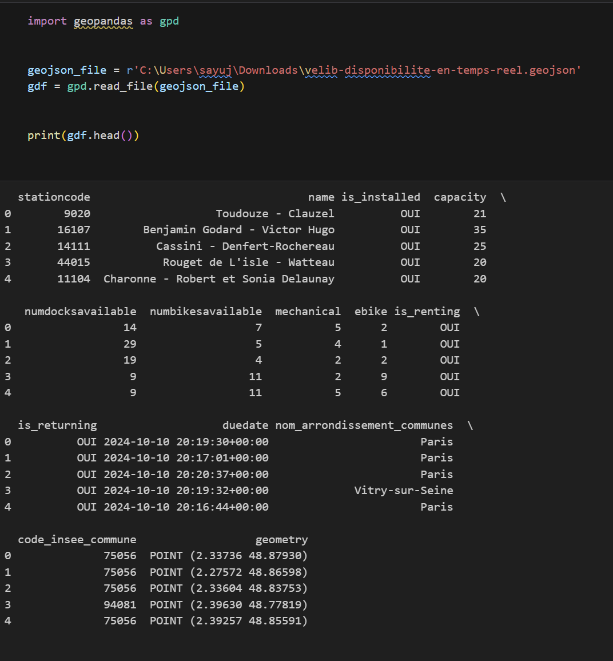
4.2 Data Preprocessing
Cleaning the Data: The dataset was filtered to remove any stations that were not installed or operational (i.e., stations not renting or returning bikes).
Clipping and Filtering: We focused on the major office zones in Paris and filtered stations based on their proximity to these zones (using coordinates and defining radii of influence around key districts).
4.3 Geospatial Mapping
Using Folium and GeoPandas, we plotted the locations of each station on a map, marking their proximity to office zones with 5km radius circles. Additionally, the stations were color-coded to reflect bike availability, with distinct colors for mechanical bikes and e-bikes.
4.4 Descriptive Analysis
Bike Availability: We calculated the total number of available bikes across all stations in the dataset, breaking it down into mechanical and electric bikes.
Dock Availability: We summed the available docks in these zones, providing insight into bike parking capacity.
Peak Usage Patterns: By identifying key office zones and their corresponding bike stations, we analyzed which stations experience high demand during peak hours (morning and evening rush hours).
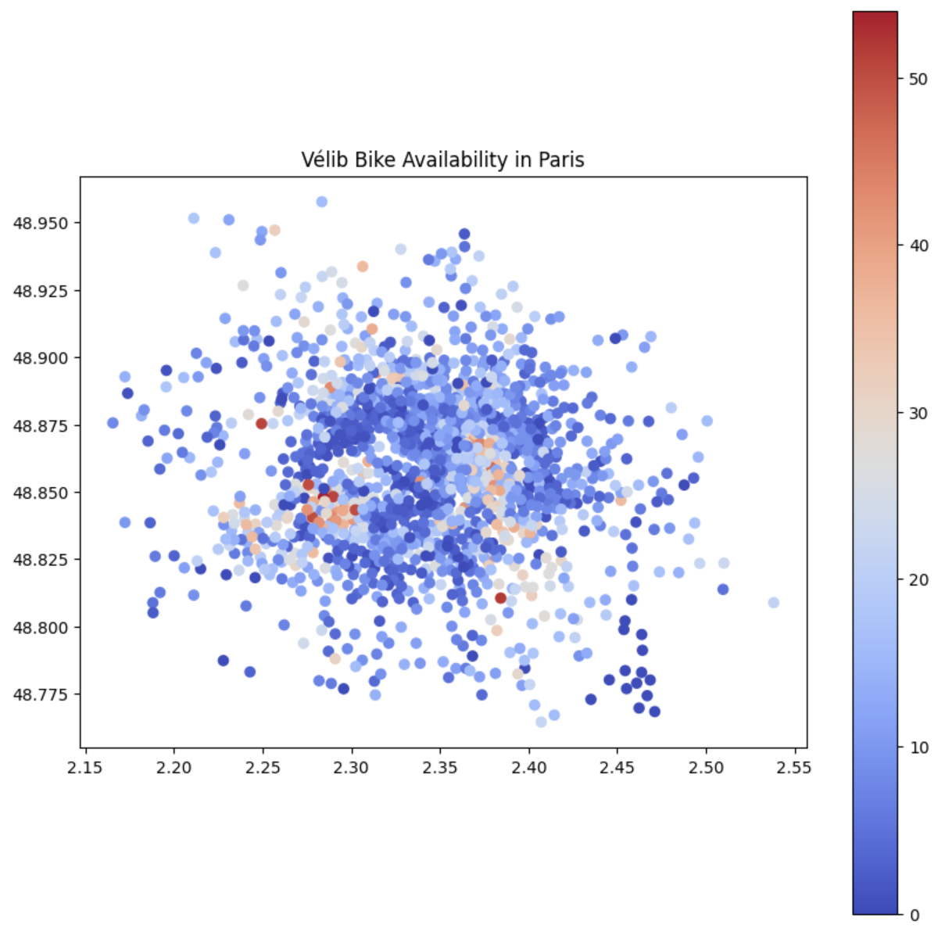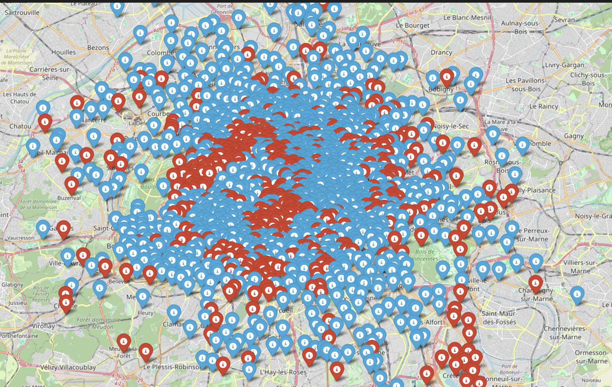
Folium Mapping of the bike availability Data.
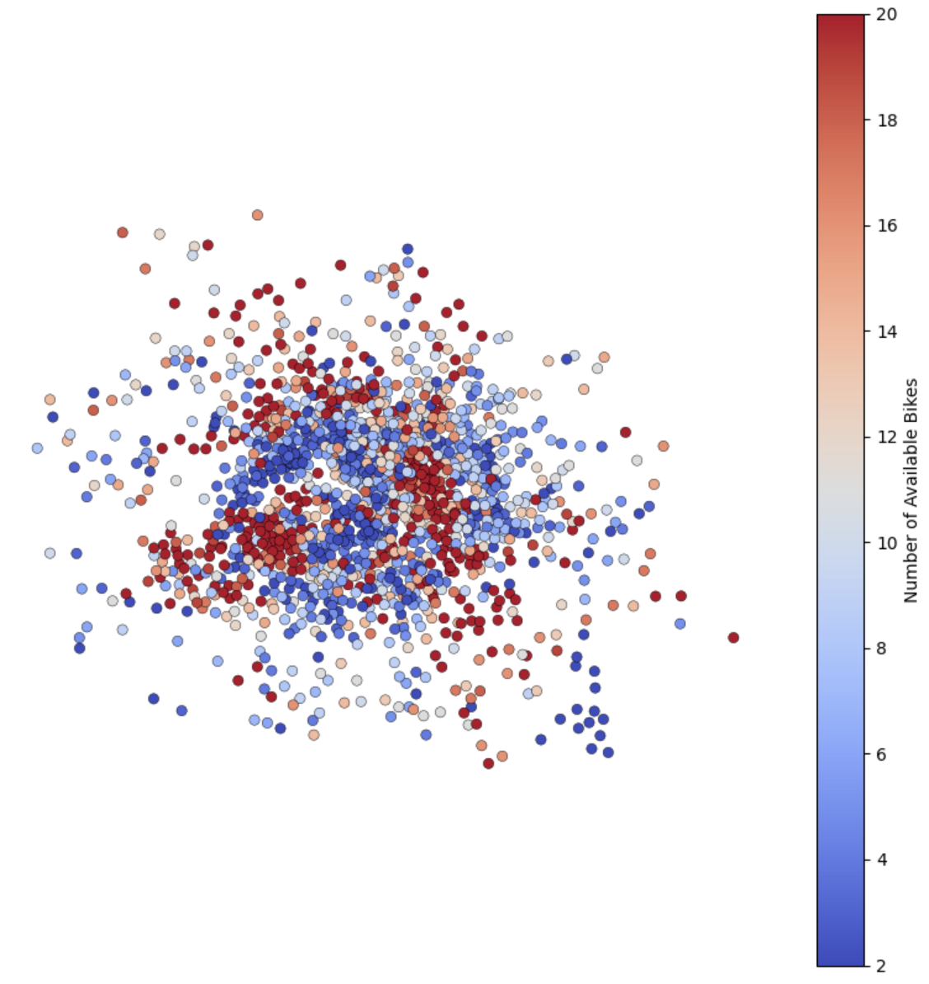
Condensing data and creating a layer for projecting the data onto a real map
5. Analysis and Results
5.1 Total Availability of Bikes and Docks

Total Bikes Available: The dataset showed that there are 17,701 bikes available across Paris at the time of analysis, with a split of 11,033 mechanical bikes and 6,668 e-bikes.

Total Docks Available: There are 26,599 docks available for parking bikes across all stations.

5.2 Distribution Across Office Zones
The highest concentrations of bikes were found near major office zones such as La Défense and Saint-Lazare, where commuters frequently rely on bike rentals for the "last mile" of their journey. These zones also showed fluctuations in availability during peak hours, indicating a potential need for better dock management.
5.3 Insights on Mechanical vs. Electric Bikes
Electric bikes, though fewer in number, are increasingly popular due to the ease of use on long commutes. In office zones like Montparnasse and Opéra, e-bike usage saw a marked increase, especially in the morning.
6. Visualizations
Several visualizations were created to map and highlight the findings:

Geospatial Heatmaps: Using Folium, we generated heatmaps showing the density of bike stations and availability of bikes in real-time, color-coded by the type of bike (mechanical or electric). A condensed data was produced to plot it onto a real map and finally software's like QGIS and photoshop was used to finalize the visualization.

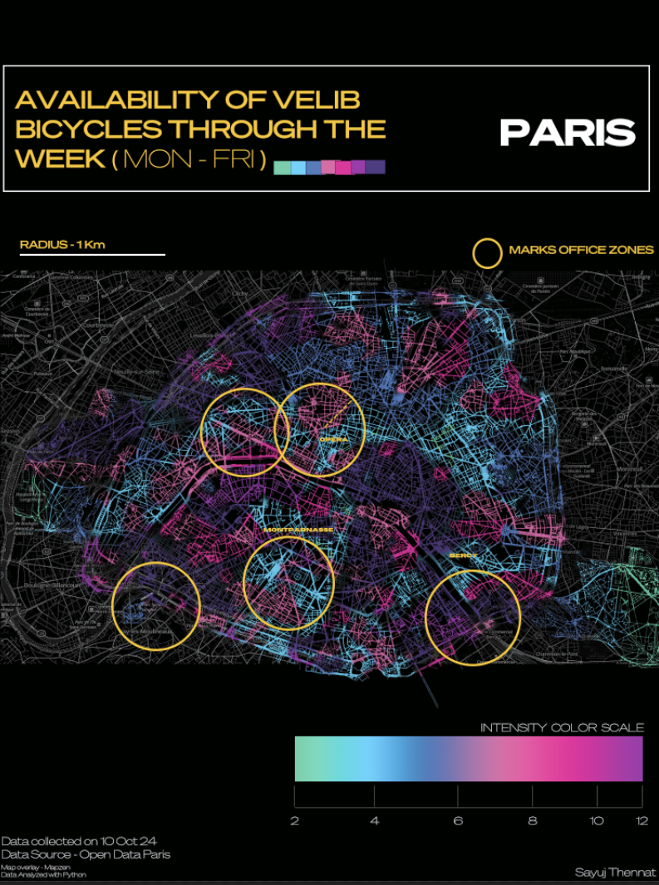
8. Future Work
Building on this foundational analysis, the next steps will include:

Time-Series Animation: An animated visualization that tracks how bike availability fluctuates in office zones throughout the week. This can help identify peak hours and areas with chronic shortages.

Predictive Modeling: Use machine learning models to predict bike demand in different zones, allowing better station and dock planning.

Policy Recommendations: Based on the analysis, recommendations will be made to city planners regarding optimal locations for new bike stations and better redistribution of bikes during peak hours.

9. Conclusion
This project offers a comprehensive look at bike availability across major office zones in Paris, highlighting key trends in urban mobility. The data-driven insights can be valuable for improving infrastructure, planning for better bike-sharing services, and ensuring that commuters have access to efficient, sustainable transport options.
With future plans to expand this project into animated time-series visualizations and predictive modeling, this analysis lays the groundwork for smarter urban mobility solutions in Paris.

Project Documentation: UEFA EURO Performance Visualization 2008-2020


Sayuj Thennat

Project Overview

Project Title
UEFA EURO Performance Visualization 2008-2020

Project Description
This project focuses on visualizing the performance of some of the top football teams in the UEFA European Championship from 2008 to 2020. The visualization captures the number of goals scored by each team in various stages of the tournament, using concentric circles to represent the goals scored in each stage. The project aims to provide an engaging and insightful look into the teams' performances over the years through the power of data visualization.

Objectives

To create an engaging and informative visual representation of UEFA EURO tournament performances.

To highlight the progression of each team through different stages of the competition.

To showcase the number of goals scored by each team in a visually appealing manner.

Tools and Technologies

Design Software: Adobe Illustrator

Data Analysis: Microsoft Excel, Python

Visualization: Custom graphics and design elements

Data Sources

UEFA official statistics

Historical match data from UEFA European Championships (2008, 2012, 2016, 2020)

Methodology

Data Collection

Gather Historical Data: Collected data on the number of goals scored by each team in the UEFA European Championships from official UEFA sources and databases.

Data Cleaning: Cleaned and organized the data to ensure accuracy and consistency for visualization purposes.

Data Analysis

Data Segmentation: Segmented the data by year, team, and stage of the competition (Group Stage, Round of 16, Quarter-finals, Semi-finals, Finals).

Goal Totals: Calculated the total number of goals scored by each team in each stage.

Visualization Design

Concept Development: Developed the concept of using concentric circles to represent the number of goals scored in each stage.

Design Elements: Used Adobe Illustrator to create custom graphics that visually represent the performance of each team.

Annotations: Added annotations to explain key aspects of the visualization, such as tournament winners, penalty shootouts, and progression stages.

Visualization Explanation

Key Features

Concentric Circles: Each set of concentric circles represents the advancing stages of the competition. The number of circles indicates the number of goals scored in that particular stage.

Color Coding: Different colors are used to distinguish between stages and highlight significant events such as penalty shootouts.

Annotations: Clear annotations provide context and explanations for the visual elements, making the visualization easy to understand.

Team Performance Highlights

Portugal: Showcases consistent performance with goals scored across multiple stages, highlighting their journey through the tournaments.

Spain: Emphasizes their winning performance in 2008 and their goal-scoring prowess in various stages.

Germany and France: Visualized to reflect their strong performances and progression through different stages.

Italy: Highlights their victorious 2020 campaign with notable goal-scoring in the final stages.

England: Reflects their performances, including stages where they did not qualify.

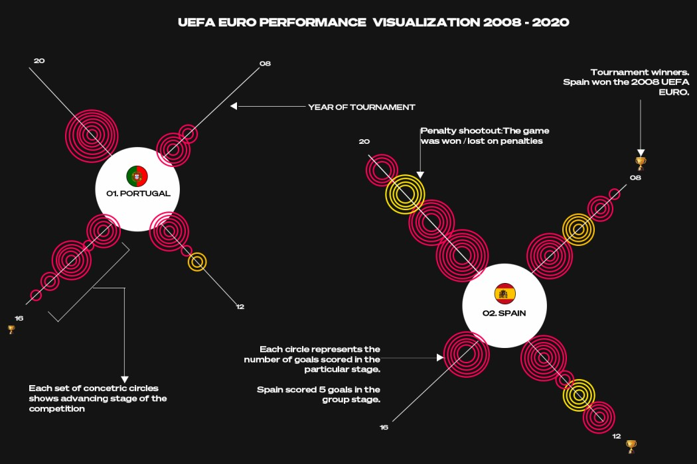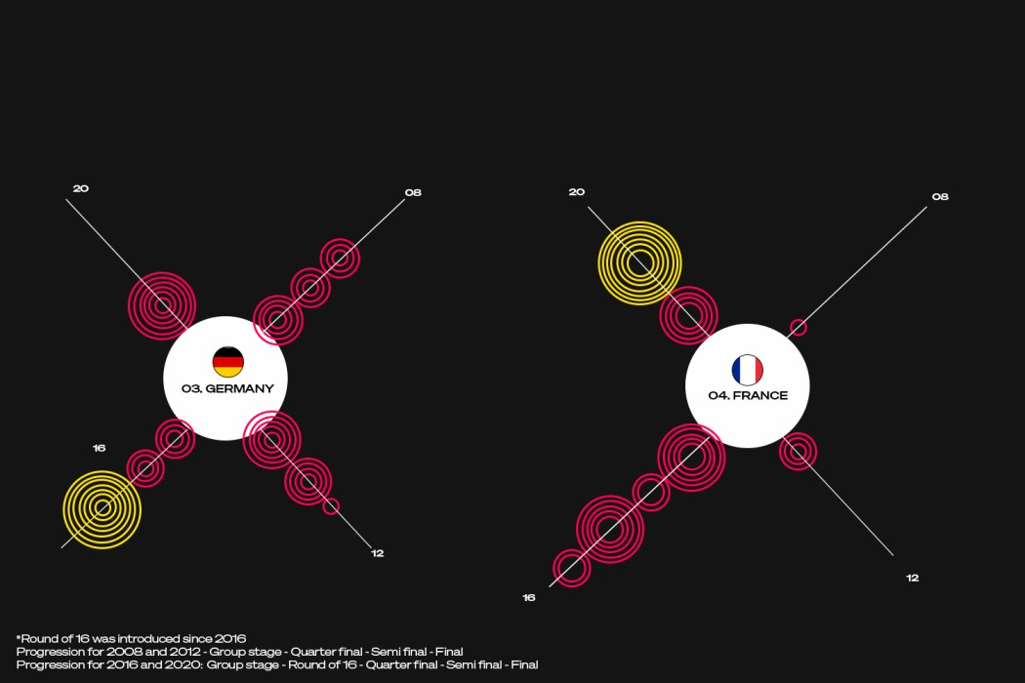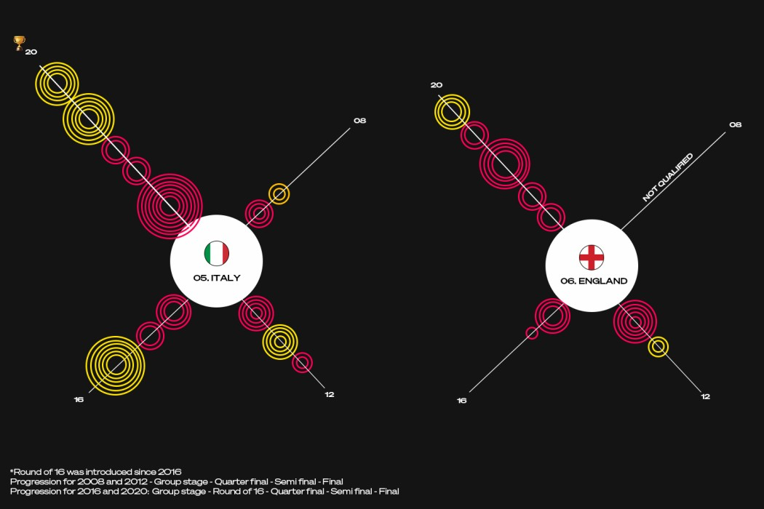

Results

Engagement: The visualizations provide a clear and engaging way to understand the performance trends of top teams in UEFA EURO competitions.

Insights: The project highlights how data visualization can turn raw data into meaningful and insightful visual narratives.

Conclusion
This project successfully combines the worlds of football and data visualization to create an engaging representation of UEFA EURO performances. It demonstrates the potential of data visualization to provide deeper insights and enhance the storytelling of sports analytics.

